**Status**: In Technical Refinement. **Pending with** : Shahid

Leave-Work Week

Info

<https://employsure.com.au/blog/employee-leave-entitlements-gets-can-take/>

<https://www.simplepay.co.za/help/employee-self-service/leave-requests>

Work Week keep Working Days

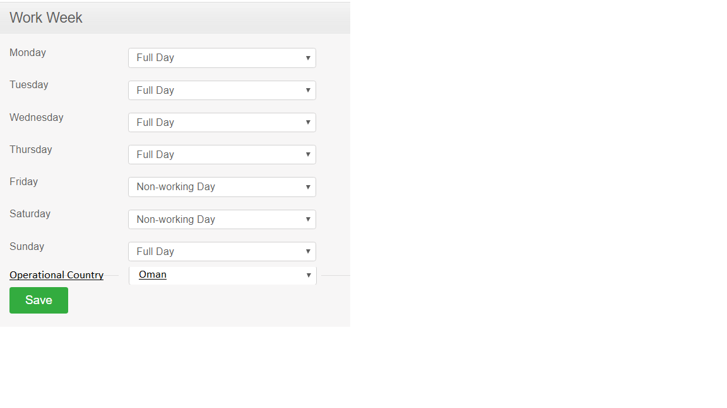

Acceptance Criteria

1. User will be able to select operational country , from table operational_country

Shahid >> Get service required.

As of now default country will be displayed and selected Oman. Icon will be based on country.

1. Full Day will go in DB as 8 and Half Day will go as 4.

Shahid >> Please confirm in real DB what is saved.

1. For one operating country , only one record will be in DB.
2. As of now default country is only one Oman.
3. Same record will be added first time , next time it will only update.
4. When Mange Work Week link is clicked same page open .
5. Full Day, Half Day, Non-Working-Day , will come from DB.

Shahid >> to confir and write service.

|  |  |
| --- | --- |
| Add | create |
| Search | findAll | |
| Update | update | |